1. Boot loader which does nothing

[BITS 16];

[ORG 0X7C00];

JMP $;

TIMES 510 -($-$$) db 0;

DW 0xAA55;

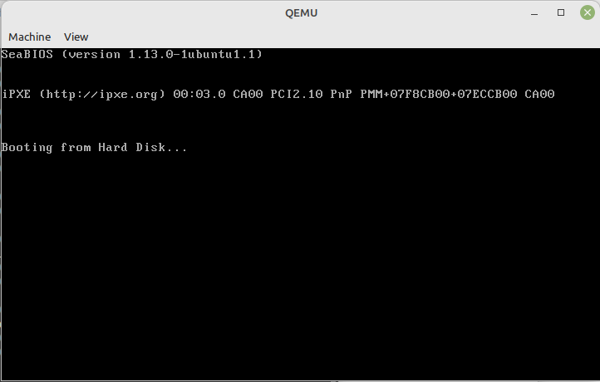

2. Printing using PRINT CHARACTER

[BITS 16]

[ORG 0x7C00]

MOV AL,65

CALL PrintCharacter

MOV AL,77

CALL PrintCharacter

MOV AL,65

CALL PrintCharacter

MOV AL,78

CALL PrintCharacter

JMP $

PrintCharacter:

MOV AH,0x0E;

MOV BH,0x00;

MOV BL,0x07;

INT 0x10;

RET

TIMES 510 -($-$$) db 0

DW 0xAA55

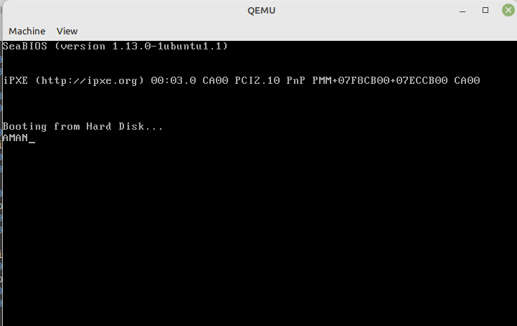

Printing only 1 character

[BITS 16]

[ORG 0x7C00]

MOV AL,65

CALL PrintCharacter

JMP $

PrintCharacter:

MOV AH,0x0E;

MOV BH,0x00;

MOV BL,0x07;

INT 0x10;

RET

TIMES 510 -($-$$) db 0

DW 0xAA55

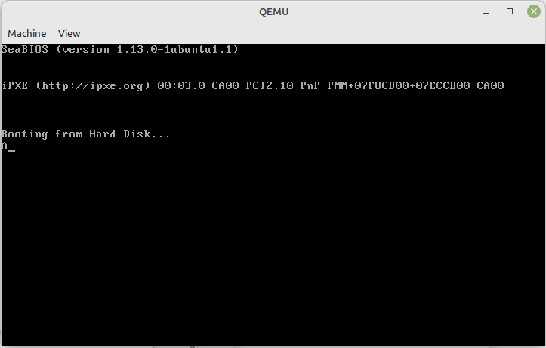

3. Printing character using load and performing or operation

[BITS 16]

[ORG 0x7C00]

BOOT:

MOV SI,HELLO;

MOV AH,0x0E;

LOOP:

LODSB

OR AL,AL

JZ HALT

INT 0x10

JMP LOOP

HALT:

CLI;

HLT

HELLO: db "21bce5769",0

TIMES 510 -($-$$) db 0

DW 0xAA55



4. Printing characters with color

[BITS 16]

[ORG 0x7C00]

JMP MAIN

MAIN:

XOR AX,AX; DS = 0

MOV DS,AX

CLD;

MOV AX,0012H;

INT 10H

MOV SI,STRING

MOV BL,5

CALL PRINTSTR

JMP $

PRINTSTR:

MOV BH,0x00;

PRINT:

LODSB

CMP AL,0

JE DONE

MOV AH,0EH

INT 10H

JMP PRINT

DONE:

RET

STRING db "OS F1 SLOT",13,10,0

TIMES 510 -($-$$) db 0

DW 0xAA55

